To: | Cabinet
Date: | 13 December 2023
Report of: | Planning policy and place manager
Title of Report: | Authority Monitoring Report and Infrastructure Funding Statement 2022/23

Summary and recommendations
Purpose of report: |  | To approve the Authority Monitoring Report and Infrastructure Funding Statement for publication.
Key decision: |  | No
Cabinet Member: |  | Councillor Louise Upton, Cabinet Member for Planning and Healthier Communities
Corporate Priority: |  | Enable an inclusive economy  Deliver more affordable housing  Support thriving communities  Pursue a zero carbon Oxford
Policy Framework: |  | The Authority Monitoring Report is a statutory requirement providing information as to the extent to which the policies set out in the Oxford Local Plan are being achieved and on the implementation of the Local Development Scheme. The scope of those policies is wide and encompasses all of the Council’s corporate priorities.  The Infrastructure Funding Statement is a factual report and statutory requirement which summarises the amount of developer contributions (Community Infrastructure Levy (CIL) and Section 106) obtained, allocated and spent by the authority in the previous financial year (April 2022 – March 2023).
Recommendations: That Cabinet resolves to:
1. | Approve the Authority Monitoring Report and Infrastructure Funding Statement 2022/23 for publication; and
2. | Authorise the Planning Policy and Place Manager to make any necessary minor corrections not materially affecting the document prior to publication.

Appendices
Appendix 1 | Authority Monitoring Report 2022/23
Appendix 2 | Infrastructure Funding Statement 2022/23
Appendix 3 | Risk Assessment
Appendix 4 | Equalities Impact Assessment

Introduction and background
- Section 35 of the Planning and Compulsory Purchase Act 2004 requires local planning authorities to publish monitoring reports at least yearly in the interests of transparency.
- The Authority Monitoring Report (AMR) 2022/23 assesses the effectiveness of planning policies contained within the Oxford Local Plan (OLP) 2036 as well as the implementation of the Oxford Local Development Scheme 2023-2028, the Council’s Statement of Community Involvement in Planning and the Duty to Cooperate. The AMR covers the period 1st April 2022 to 31st March 2023 and is a factual document.
- The AMR is structured as follows: a status report on the production of development plan documents, followed by the monitoring of the Oxford Local Plan 2036 policies. Policy monitoring has been arranged around the three overarching objectives set out in paragraph 8 of the National Planning Policy Framework (NPPF) 2023:
- Economic objectives to build a strong, responsive and competitive economy - the economy, retail, community and infrastructure;
- Social objectives to support building strong, vibrant and healthy communities – housing, health and community benefits; and
- Environmental objectives to project and enhance our natural, built and historic environment – design and heritage, protecting our green and blue spaces and making wise use of our natural resources to secure a good quality local environment.
- The Infrastructure Funding Statement (IFS) is a reporting requirement introduced in September 2019 as an amendment to the Community Infrastructure Levy 2010, with the objective of increasing transparency around how developer contributions are spent on infrastructure. As set out in Appendix 2, the contents of the IFS are divided into three key sections for the previous financial year:
- Information on Community Infrastructure Levy (CIL) contributions;
- Information on Section 106 contributions (made under section 106 of the Town and Country Planning Act 1990);
- Items of infrastructure that CIL is to be spent on in the next five years (CIL is allocated to the Council’s Capital Programme as part of the Budget setting process).

Key AMR findings: Building a strong, responsive and competitive economy

Employment land
- Oxford’s highly constrained nature means that competition for different land uses is fierce. As such Policy E1: Employment Sites sets out how employment sites are categorised in order of importance and thus afforded different levels of protection. Category 1 & 2 employment sites are key in providing employment space for the city, whereas Category 3 sites and B8 sites provide more potential to be released from employment uses to ensure the best and most efficient use of land.
- Permissions granted resulting in the net loss of Category 1 & 2 employment floorspace: Crown House, 193 Cowley Road (category 2);
- Total loss of Category 3 employment floorspace: 1,978m²;
- Total gain of employment floorspace: 8,828m²;
- Applications for changes of use from office to residential which are subject to notification to the council: 2 applications granted.

Growth of Oxford’s universities
- The City Council is committed to supporting the sustainable growth of the two universities within the parameters of competing demands for land. The universities are encouraged to focus growth on their own sites by making the best use of their current landholdings as well as the redevelopment and intensification of their assets where appropriate. Policy E2: Teaching and Research states that new or additional academic floorspace will only be granted if it is demonstrated that additional student accommodation is not required or is provided as set out in Policy H9: Linking the delivery of new/redeveloped and refurbished university academic facilities to the delivery of university provided residential accommodation.
- The University of Oxford had 26,497 students attending the University and its colleges as of 1st December 2022; of these 11,844 were excluded from accommodation needs as they were not on full time taught courses leaving 14,653 full-time students with accommodation needs. On 1st December there were 13,975 accommodation places provided, leaving a total of 678 students living outside of university accommodation which is within the threshold set out in policy H9 for the University of Oxford. This figure represents a significant reduction when compared to the previous monitoring period (2021/22 - 1,491).
- Oxford Brookes University (OBU) had 16,050 students attending the university as of 1st December 2022 of these 8,519 were excluded from accommodation needs leaving 7,531 full-time Oxford Brookes students requiring accommodation. On 1st December 2022 there were 4,623 student places provided leaving 2,908 students without a place in university provided accommodation living in Oxford. This is below the threshold set out in policy H9 for Oxford Brookes. This figure represents an increase in the number of students outside of university provided accommodation when compared to previous monitoring periods (2020/21 – 2,873; 2021/22 - 2,633).
- Approved additional academic and administrative floorspace: 26,316.1m²;
- Number of University of Oxford students living outside of provided accommodation: 678 – within policy H9 threshold;
- Number of Oxford Brookes students living outside of provided accommodation: 2,908 – within policy H9 threshold.

Ensuring the vitality of our centres
- Oxford provides a wide range of services and facilities to both residents and visitors alike as such, policies have been drafted in the OLP 2036 to maintain and enhance the city’s vibrancy and vitality. Policy V1 aims to protect the town, district and local centres whilst Policies V2-V4 provide the framework as to what mix of uses would be acceptable. Although the old use classes and policy thresholds are now defunct, the AMR now reports on the current percentage share of the updated use classes and how they may have changed since the previous report.

Sustainable tourism and cultural venues, community facilities and infrastructure
- Tourism is an important and substantial element of Oxford’s economy. The provision of short stay accommodation allows more options for tourists to stay over in the city and thus bring more money into the local economy. Policy V5: Sustainable Tourism seeks to locate new tourist accommodation in accessible locations to reduce dependency on the private car, in addition the policy does not permit new accommodation if it would result in the loss of residential dwellings. New tourist attractions in the city must be easily accessible by active travel or public transport and be well related to existing tourist and leisure facilities. Policies V6 and V7 seek to protect cultural, social and community facilities.
- Planning permission granted for additional hotel bedrooms: 130, all of which were granted at The Deaf and Hard of Hearing Centre.
- Planning permission granted for a 9-bedroom guesthouse: 193 Cowley Road
- Planning permission granted for change of use of 11 bed hotel to 4 x C3 dwellings: 326 Abingdon Road

Key AMR findings: Building strong, vibrant and healthy communities

Housing
- In this monitoring year 554 (net) dwellings were completed in Oxford of which 273 were affordable dwellings. This includes the equivalent numbers calculated through the application of ratios for communal accommodation (student completions and other communal accommodation). Whilst the number of completions in the 2022/23 monitoring year has fallen below the Local Plan’s annual requirement, the cumulative number of dwellings completed in the 7 years since the start of the Local Plan period (2016/17 to 2022/23) is 3,780 dwellings (net). The housing trajectory had projected that by 2022/2023, 3,509 dwellings (net) would have been provided (Figure 1).

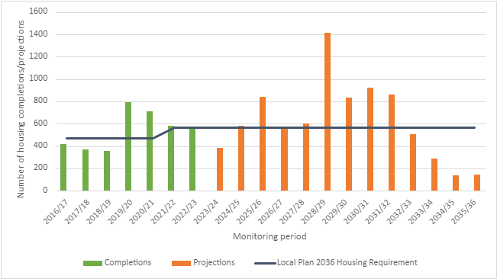
Figure 1: Local Plan 2036 Completions and Projections

- Figure 2 below shows the cumulative requirement is ahead of the projection and is on target to meet the minimum of 10,884 dwellings to 2036 as set out in policy H1.
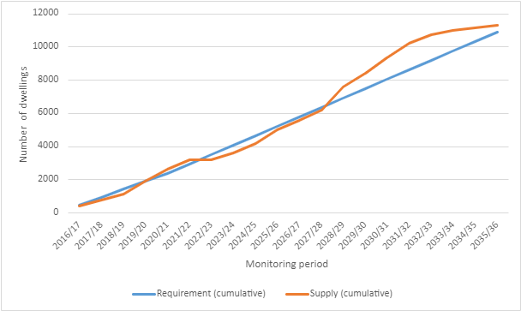
Figure 2: Cumulative Requirement and Cumulative Supply
- The breakdown of the 273 affordable dwellings completed during the monitoring year is as follows: 40 social rent dwellings at Barton Park Phase 3 (19/00518/RES), 4 social rent dwellings at St Nicholas Place (17/03050/FUL), 107 social rent and 71 shared ownership dwellings at Littlemore Park (18/02303/RES), 8 social rent dwellings at former Wolvercote Paper Mill (18/00966/RES), 16 social rent, 2 intermediate rent and 20 shared ownership dwellings at former Murco Service Station (18/03287/FUL and 22/01661/VAR) and 5 social rent dwellings at St Paul’s House, Walton Street.
- Since the start of the Local Plan period there have been a total of 937 affordable homes built (Figure 3).
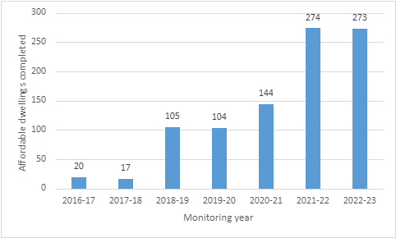
Figure 3: Net affordable dwellings completed 2016/17 - 2022/23

- The Council is committed to delivering more affordable housing in Oxford and has been identifying land in its ownership capable of delivering affordable homes and bringing this forward wherever possible. Of the 273 affordable dwellings completed in 2022/23, 83 were delivered on City Council Land.
- Net dwellings completed in 2022/23: 554 of which 273 were affordable:
- Affordable units delivered on council land in 2022/23: 83,
- Net dwellings permitted in 2022/23: 1,209; of which were affordable: 383.

Provision of new student accommodation
- There were 2 planning permissions for student accommodation all of which were compliant with the location criteria set out in Policy H2.
- Applications for new student accommodation: 2.

Housing land supply
- The Plan’s annual housing requirement is used to calculate the 5-year housing land supply as set out in the NPPF. The Council has identified a deliverable supply of 2,955 homes which includes the forecast supply from large sites, including those which have been allocated in the Local Plan and outstanding permissions from small sites (commitments) plus a windfall allowance. This gives a housing land supply of 5.49 years which is very similar to the figure reported in last year’s AMR.

- Whilst Figure 2 above indicates that the forecast supply drops below the requirement over the next five-year period, over the longer term the forecast supply is always above the requirement, with the gap between the two increasing from year 6 (28/29). Work on the Local Plan 2040 has provided further updates on the anticipated delivery of some of the large trajectory sites, alongside a further round of landowner engagement to inform our Housing and Economic Land Availability Assessment (HELAA).
- Housing land supply: 5.49 years.

Key AMR findings: Oxford’s Historic Environment
- There are two buildings are on English Heritage’s at-risk register.

Key IFS Headlines:
- The IFS reports on the developer contributions received, allocated and spent for 2022-23.
- £2,096,995.17 of CIL was collected in 2022-23 and £2,215,869.50 of CIL was spent towards infrastructure projects. A further £2,731,229.02 of CIL was set out in demand notices in the year for collection;
- Of the £2,215,869.50 spent, £1,379,850.00 was spent on strategic infrastructure; £81,935.49 was passed to Parish Councils; £649,897.94 was allocated or spent towards Neighbourhood forums and Neighbourhood CIL and £104,186.07 was spent on administration fees;
- In 2022-23, £360,588.57 was received in Section 106 agreements and £20,072.54 was spent towards infrastructure projects. A further £878,560.00 of S106 agreements were entered into in the year;
- From the total of £13,945,694.31 received under Section 106 planning obligations (but not spent in the year 22-23), contributions are allocated to be spent on primarily affordable housing (£12,294,478.39, 88%); followed by open space/green infrastructure (£1,106,153.26, 8%); Community facilities (£237,000.00, 2%) Highways/transport and travel (£227,029.75, 2%); and Other/Economic development uses (£81 032.91, <1%);
- 87 units of Affordable housing are to be provided from Section 106 agreements entered into in 2022-23.

Carbon and Environmental Considerations
- There are no specific carbon and environmental implications arising from this report. Policies in the Local Plan are seeking to optimise opportunities for carbon reduction. This statutory framework brings us closer to our commitment to becoming a Zero Carbon Council by 2030 or earlier and Zero Carbon Oxford by 2040 or earlier.

Financial implications
- There are no financial implications arising from these reports. The IFS simply reports on the collection and spending of monies through the Community Infrastructure Levy (CIL) and S106 developer contributions.

Legal issues
- The publication and content requirements of the AMR (Appendix 1) are set out in section 35 of the Planning and Compulsory Purchase Act 2004 and regulation 34 of the Town and Country Planning (Local Planning) (England) Regulations 2012.
- The requirements for the publication and content of the IFS (Appendix 2) are set out in Regulation 121A and Schedule 2 of the Community Infrastructure Levy Regulations 2010.

Level of risk
- A risk assessment has been undertaken and the risk register is attached (Appendix 3).

Equalities impact
Report author | Alexander Sutton / Lan Nguyen
Job title | Planner, Planning Policy  Senior Data Analyst, Planning Policy
Service area or department | Planning Policy, Planning Services
Telephone | 01865 529137/ 252509
e-mail | asutton@oxford.gov.uk/  lnguyen@oxford.gov.uk
Background Papers: None
- Please refer to Equalities Impact Report (Appendix 4).

https://www.gov.uk/government/publications/national-planning-policy-framework--2

